**Installation**

1. Unzip react-webapp
2. Run “npm install”
3. Run “npm install aws-sdk”
4. The package.json will look like

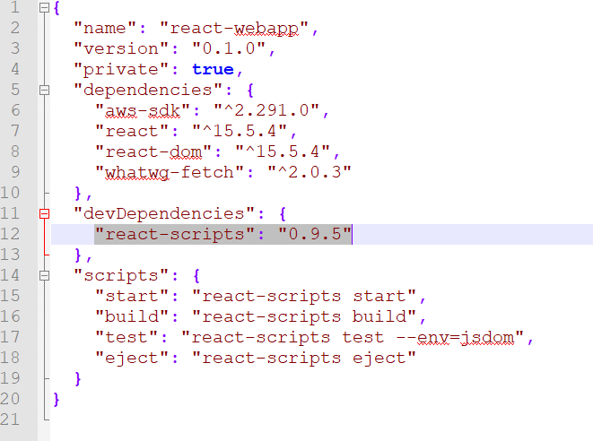

1. Run “npm start”
2. Open the chrome browser and launch the mentioned url

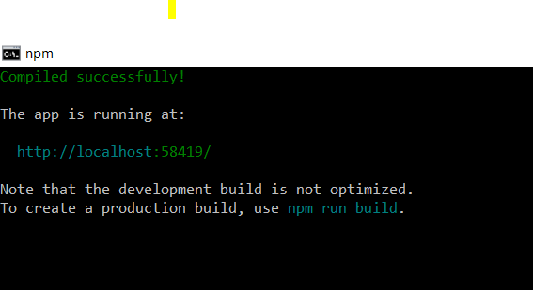

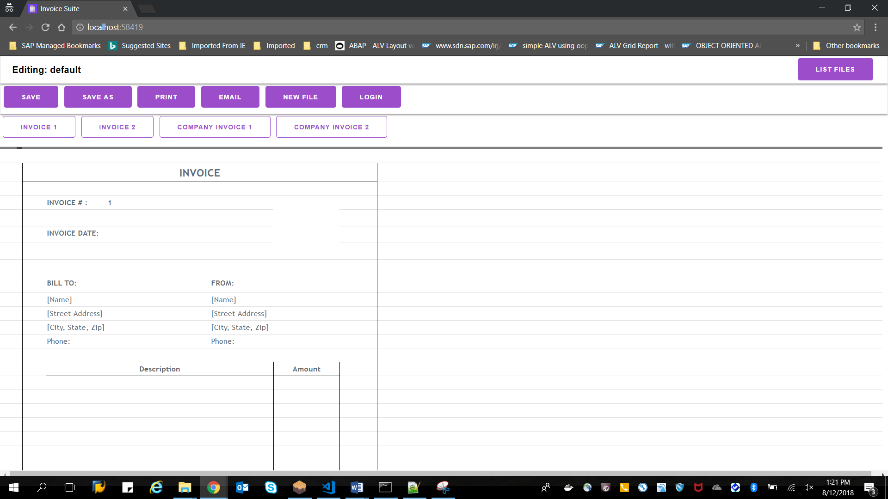

**Test Document**

1. Launch the application

